Week 1 Findings Report
Table Relationship Mapping (Entity Relationship Diagram)
Heavy Supplier, Inventory & Warehouse Analytics — CadetX Virtual Work Experience

Overview
Building on the primary/foreign key mapping already shared, this document presents the full Entity Relationship Diagram (ERD) for all 12 tables in the dataset — showing how every table connects to the others.

Entity Relationship Diagram
Live, interactive version (zoomable, click stock_ledger to see the reference note): https://dbdiagram.io/d/6aa7107436f9982564809e24
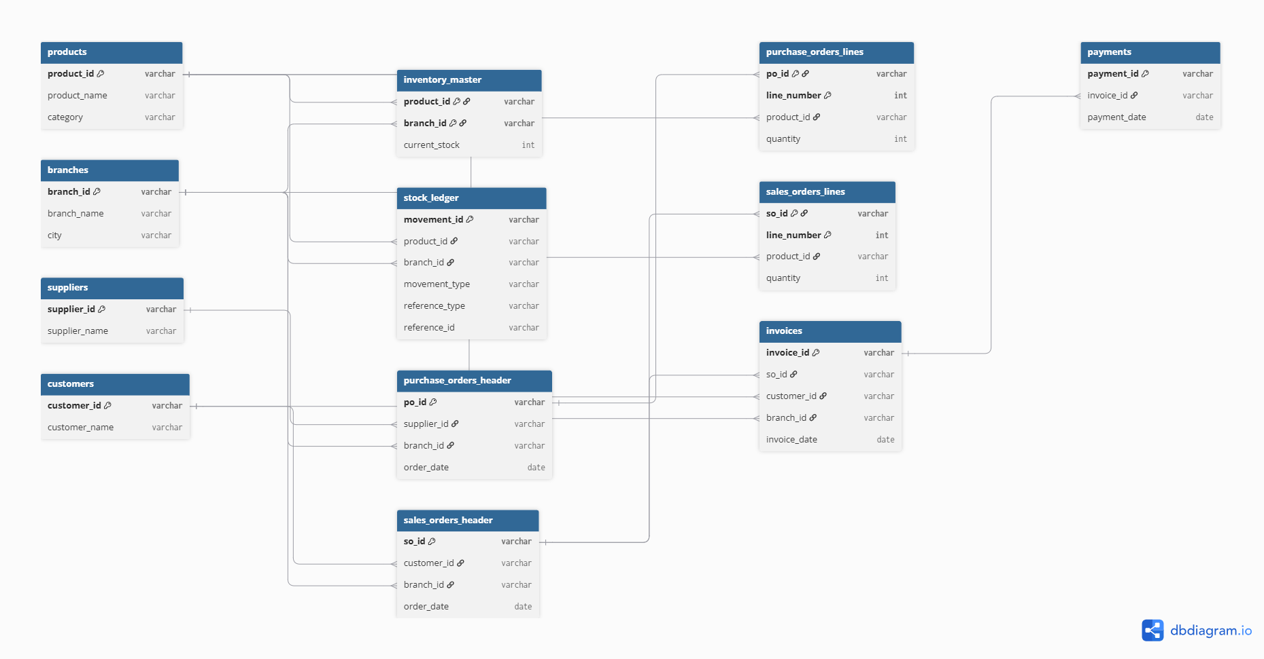

How to read this diagram
- Each box represents one table, listing its columns.
- A key icon next to a column marks it as part of that table's primary key (the column, or combination of columns, that uniquely identifies each row).
- Lines connect a foreign key in one table to the primary key it references in another.

Structural groupings

Standalone master tables
products, branches, suppliers, and customers each describe a single type of entity on their own, with no foreign keys referencing other tables. Other tables reference them, but they don't reference anything themselves.

Composite-key tables
inventory_master, purchase_orders_lines, and sales_orders_lines each exist specifically to connect two other things together, and require two columns combined (rather than one column alone) to uniquely identify each row:
- inventory_master: product_id + branch_id (this product, at this branch)
- purchase_orders_lines: po_id + line_number (this line item, within this purchase order)
- sales_orders_lines: so_id + line_number (this line item, within this sales order)

A note on stock_ledger's flexible reference
stock_ledger.reference_id is not drawn as a single fixed link in the diagram, because it can point to either purchase_orders_header (when reference_type = 'PO') or sales_orders_header (when reference_type = 'SO'), depending on the row. This kind of conditional relationship can't be represented as one fixed line, so it's documented here instead: reference_id links to either purchase_orders_header.po_id or sales_orders_header.so_id, depending on the value of reference_type.

